Plugs For
Computer
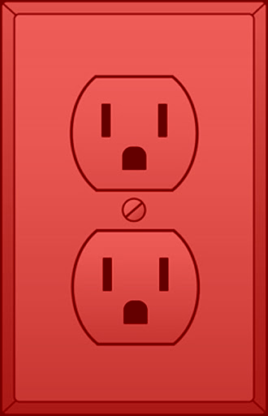
and
Light
Show
Only

Nothing else,
No exceptions

Use the Orange Extension Cord if you need to plug something in.

